Mitigation Planning
In November 2021, with the concurrence of the State Historic Preservation Officer, CDOT sent a written invitation to a number of area civic, veterans and governmental entities asking them to join a Mitigation Working Group to develop a plan for the preservation, monitoring and perpetual maintenance of the pillars. The Working Group is headed by Boulder Rotary Club, and among the additional organizations that have become involved with its work are (in alphabetical order):
Boulder American Legion Post #10
Boulder Chamber of Commerce
Historic Boulder
Indian Peaks Chapter, NSDAR
Lafayette Chamber of Commerce
Lafayette Historic Preservation Board
Lafayette Historical Society
Museum of Boulder
VFW Mile High Post (Lafayette)
YMCA of Northern Colorado
In addition, staff members from the County of Boulder, the City of Lafayette, and the Carnegie Library for Local History have provided support for the Working Group’s investigations.
The Working Group’s initial effort was to hold public informational sessions in Lafayette and Boulder to provide more information and details concerning the history and current status of the pillars.
At the same time, the Working Group has analyzed the potential alternatives for mitigating the adverse impacts on and preserving the pillars. As part of that work, restoration specialists inspected the pillars and began developing technical alternatives for their restoration and preservation.
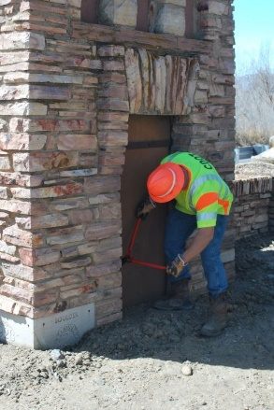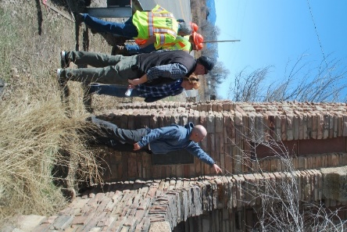
The professional specialists have indicated that if the pillars are to remain in their current location, work must be done to repair and restore the masonry and other portions of the structures. If the pillars are relocated, given its age and relative fragility, the south pillar must be disassembled and the salvageable stones categorized. After those stones are transported to the new location, the salvaged stones along with needed replacement stones would be reassembled in the original design.
Though further investigation is needed, it may be possible to move the north pillar, which was rebuilt in 1983, by dividing the tower portion of the monument into three sections, moving each section to the new location, and reassembling the pillar. If it is determined after further investigation that this technique is not feasible, then the north pillar must be disassembled and moved in the same fashion as the south pillar.
Until a final decision has been made, an exact cost estimate has not yet been developed. However, it is anticipated that the total cost of any relocation will be several hundred thousand dollars.
On April 12, an in-person and virtual public forum was held with representatives of CDOT and Boulder County to discuss various alternatives that had been proposed, and solicit public input regarding the pillars’ future. Based on the public input, the Working Group began investigating the desirability and feasibility of a handful of these alternatives.
In late July 2022, the Working Group met to discuss the results of these investigations. Some members expressed support for leaving the pillars in their current locations, notwithstanding the recent reconfiguration of the intersection, Others felt that this option was not feasible, and that the pillars should be relocated. The decision was made to begin in-depth studies and planning for three alternatives:
- Leaving the pillars in their current location
- Relocating the pillars to the NW corner of US 287 & Arapahoe Road near the present location of the pillars; and
- Relocating the pillars to Legion Park off Arapahoe Road west of 75th Street
By November 2022, the Working Group had obtained more detailed analyses and information concerning each of these sites. This information has summarized for each of the alternatives: Current Location, NW corner of US 287 & Arapahoe Road, and Legion Park.
On January 15, 2023, the Working Group held a public meeting to present these alternatives and obtain public comment. A month later, on February 14, the Working Group recommended to CDOT and SHPO that the pillars be relocated to an area roughly 150’ north of their current location in accordance with the NW Corner alternative, presented above. CDOT and SHPO are currently studying that recommendation.
Members of the public are encouraged to submit their questions and comments to the Working Group.

