Jim Swaeby Peace Award

The Rotary Club of Boulder presents the Fourth Annual Jim Swaeby Peace Award recognizing a person for outstanding achievement consistent with the ideals of Rotary: the advancement of understanding, goodwill, and peace, indeed, all Rotary projects are pathways to peace. The award con1n1e1norates the contribution of Boulder Rotarian Jim Swaeby who gave of his time, talent, humor and passion to build a better world. Jim was a Returned Peace Corps Volunteer and businessman who contributed to the community in numerous ways.

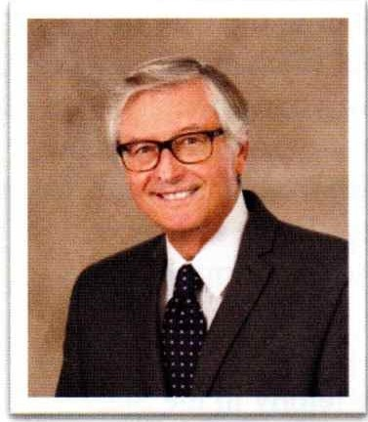
Jim Swaeby, Peacemaker was a bright inquisitive man who often had a thought to offer, perhaps in the form of an adage which suggested bow be choose to live. In his obituary following his death was such a thought, "give freely of that which costs you nothing." Jim exemplified that adage, giving of his time, talent, humor and passion. He was also generous of his resources toward the many causes that he championed.
Jim and his family moved to Boulder in the mid-50's. He was a graduate of Fairview High School where he served as Head Boy. From there be headed to the University of Colorado where he received both a bachelor and master's degree. After college, Jim became a volunteer in the U.S. Peace Corps in the Kingdom of Tonga, a small island country in the South Pacific where he started
a school to train Tongan agricultural extension agents. After nine months, his service was cut short when he was the first Peace Corps volunteer to be drafted. Jim spent thirteen months in Viet Nam with the I st Cavalry Division (Air Mobile).
Jim's early career was in banking, chiefly with the United Bank Holding Company where he was Vice President of facilities and human resources. He left that field in 1986 to join a local real estate company as a commercial broker. For most of his career he was with the Colorado Group. In 2011, Jim was recognized with the Dean Callan Commercial Realtor of the Year Award.
Jim was active in many community organizations throughout his career. He was active in historic preservation, having served as President of Historic Boulder and for many years as a Board member of the Boulder Museum of History. He was active in promoting historic preservation as a worthy goal when the Scientific and Cultural Facilities District was created.
Jim was a Board member and chair of the Boulder Urban Renewal Authority during the time of the planning for the redevelopment known as 29th Street and the St. Julien Hotel. In 1999, the Boulder Daily Camera recognized Jim as a Pacesetter in the category of business.
Jim was a very active member of Boulder Rotary. Over a 22-year period he served on many committees including the Board of Directors, Foundation Board, awards committee and the caring committee. Jim was instrumental in creating a Memorandum of Understanding establishing an ongoing link between Rotary International and the U.S. Peace Corps.
Jim is survived by his wife, Susan, of 45 years, two beautiful daughters and four grandchildren. His parting words to us exemplified his life:
Do an unexpected act of kindness or generosity for someone less privileged.

